ABSTRACT

Developing an Intelligent Robotics Course
Oskars J. Rieksts
Jeffrey W. Minton
Kutztown University
rrobe064@live.kutztown.edu
Abstract yet to be written - what is here is the abstract from Bob Roberts paper. *** We report here on a project currently in progress. The project was undertaken to add OpenCV's image processing capabilities to the Myro robotics system. This was done to augment the simple image processing included with Myro.
The environment consists of Python 2.6.4 running on Microsoft Windows XP. The software used is the Python build of OpenCV 2.0 and the SVN build of Myro from November 10th (listed as 2.8.16).
The goal of the project is to provide higher level programming primitives for the Myro user which take advantage of the capabilities provided by OpenCV. This requires the coordination of two otherwise unrelated systems. The next step is to harness the functionality of OpenCV for robotics applications. And, finally, we must abstract the workings behind functions to make the new image processing as easy to use as the old.
At present the first task has been achieved. The second is in progress and the third has not yet been initiated.

KEY WORDS
Robotics, iRobot Create, Image processing, MATLAB

1. Introduction
Today many robotics applications have a significant software component. Not surprisingly it has been recognized by both industry leaders and educators, such as Bill Gates [xxx1], David Touretzky [xxx], and Douglas Blank [xxx3], that a course focusing on the software side of robotics belongs in the undergraduate computer science curriculum. The areas of greatest commonality between robotics and software engineering occur in mobile, autonomous robotics which also require the most decision-making and intelligence of the robot. Also, the development trajectory of robotics indicates that in the near future robots will be found in the living and working spaces of people. This puts a high priority on the development of means of communication between robots and humans.
Ideally, a robotics course in the computer science curriculum would incorporate mobility, autonomy in decision-making and communication. We report here on the design and implementation of a course in intelligent robotics at Kutztown University during the Summer and Fall of 2010.

2. Course Design Objectives
For maximum impact a robotics course in the computer science curriculum should be readily accessible to the average computer science major who has no special preparation in electronics. Thus, the majority of the work expected of students in such courses would focus on software and not on hardware. And, both from the standpoint of student interest and for sound pedagogical reasons, the robot should be capable of performing tasks reasonably high on the intelligence scale.
The basic framework projected for the course was a robot operating in an environment shared with humans and in communication with humans. While the robot would be mobile and capable of autonomous action it would also be capable of taking directives from a person. This framework imposes a number of constraints on the design of the robot.
First, it must be situated and embodied in the sense of Randall Beer [xxx ...]. Right from the start the robots would be placed within an environment and emphasis would be on working with a data stream drawn from the environment, while minimizing the use of pre-existing knowledge of its surroundings. This, of course, draws upon the pioneering work of Rodney Brooks [xxx ...] and the behavior-based design described by Maja Mataric [xxx ...].
Second, there must be a set of concepts and facts about the environment shared by man and machine, as well as a communication framework common to both. Since the most natural human sensory system is vision, the ideal robot sensory system would include (and heavily feature) acquisition and processing of "visual" data.
These objectives lead to the following course topics and activities: Mastery of the software systems which control the basic operation of robot, understanding and implementation of a robot control architecture, understanding the basic concepts of image processing and mastery of specialized image processing software, understanding and implementation of the basics of communication theory, and an understanding of key philosophical issues such as the theory of referents [xxx ...], the symbol grounding problem [Harnad xxx ...], and interactivism [Bickhard, xxx ...].
The challenge is to cover these topics in a non-trivial way while keeping the course accessible to a sufficiently wide audience.

3. The Hardware and Software Platform
In order to meet the above course objectives an appropriate hardware and software platform must be in place. Desired properties of such a platform are a plug-and-play type of boot up of the robot, a good sensor and actuator suite, hardened (robust) hardware components, an API to enable higher level programming of the robot and an over-arching software system to tie it all together.
This combination of desiderata, it turns out, is not easy to achieve at a cost accessible to the small to medium sized university budget. For the past five years the first author has offered aspects of robot programming in a special topics course and within artificial intelligence courses. Various hardware and software platforms have been been used: hacked Roombas from iRobot, Lego Mindstorms kits running the original software and running Lejos, Vex robotics kits, the Myro "personal robot," and various robotic configurations assembled from components.
This early experience constituted a valuable learning curve in two respects. First, it brought into sharper focus the necessary features of a workable system. Second, it showed that there was significant interest in robotics among computer science students.

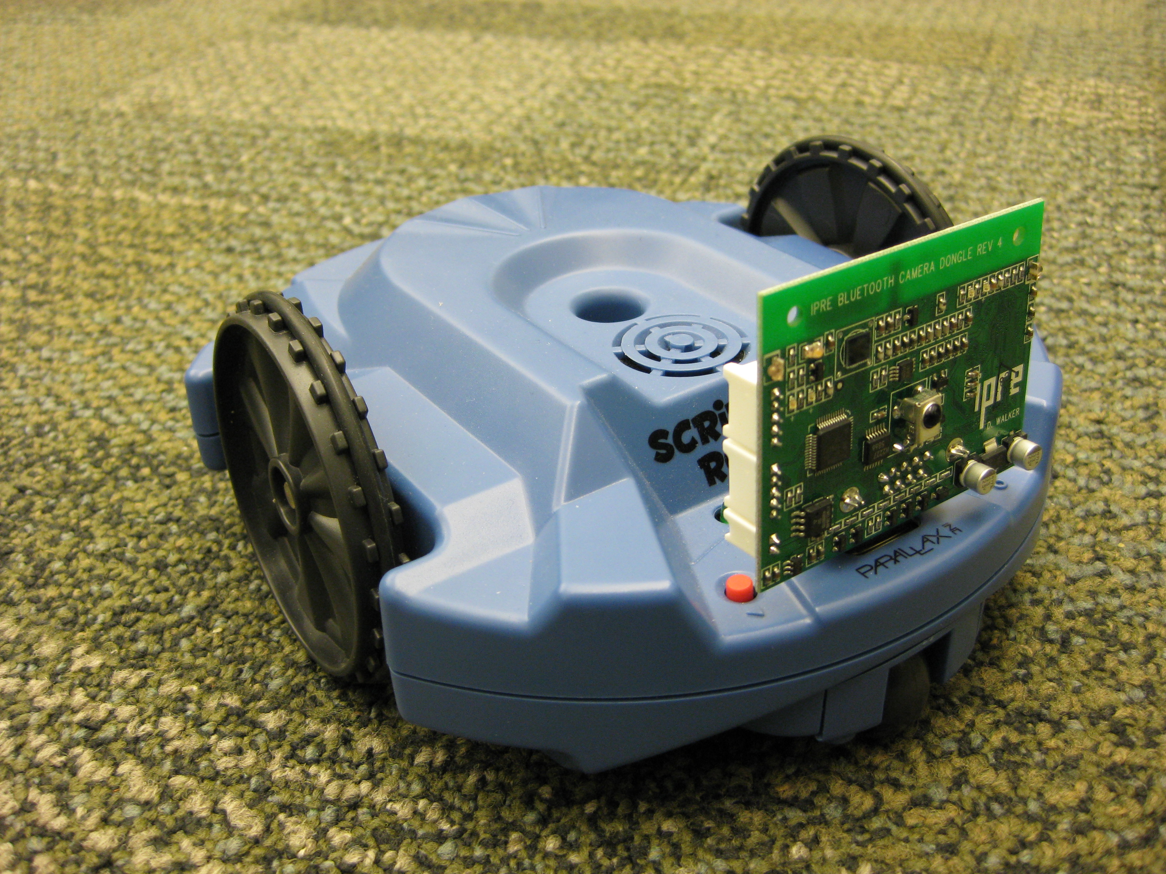
Figure 1: The Create robot with camera, Arduino and netbook

Late in the spring of 2010 the first author received an SSHE Faculty Professional Development grant to develop an intelligent robotics course. The second author, a graduate student, worked with him on this project during the summer and fall of 2010. He had previously built a robot to enter the Trinity Fire Fighting Robot competition which consisted of a repurposed Vex chassis augmented with camera, sonar and IR sensors and controlled by an onboard netbook in concert with an Arduino microcontroller.
The design goal of the robotic platform for the course was a combination of hardware and software which would afford the opportunity for significant intelligence in control and decision-making. In addition, we wanted the configuration to have an open-ended quality which would allow the course content to grow, with time, in complexity and challenge. In particular, a major goal for us was to aim for communication and collaboration between robot and human. This was inspired by the success of Kantrol {Sp} [xxx . .] and other similar systems, but also by the clear need for robot-human communication for any viable robotic wheelchair system. This pushed us toward continuing with the use of a camera as a major source of information about the environment. Our collective experience gave us a predilection to using the design of the fire fighting robot as a starting point and making appropriate adjustments.
In addition to taking advantage of previous experience (and striving to overcome the shortfalls of previous systems), the authors drew upon the significant experience of John Spletzer [xxx ..] of Lehigh University and consulted also with John Grenzer, Vice President for Technology of The Good Shepherd Rehabilitation Hospital. Spletzer teaches a robotics course in the Computer Science Department at Lehigh, was a team leader for the Little Ben entry in the DARPA Urban Challenge [xxx ..], and is lead developer of a self-stowing robotic wheelchair [xxx . .]
Since the computer science department already had several iRobot Creates, to keep costs down it made sense to use them as the basis and to add an onboard computer for the control software. This was similar to the setup Spletzer used for his robotics course and in conversations we were assured that it was a viable platform. The onboard computer was to be an Asus Eee PC 1000HA which contains an embedded camera, but as we wanted a camera with a wider view we chose the Microsoft LifeCam for its 71 degree viewing angle. As in the fire fighting robot an Arduino microcontroller gave us the flexibility of adding sensors, though at this point the only sensor we have added is the Sharp GP2Y0A02YK0F IR rangefinder.
In terms of software, the initial plan was to run Ubuntu Linux with Python as the main programming language and to use OpenCV [xxx . .]for image processing. It soon became clear that OpenCV did not provide a an entry point at a sufficiently low level for the average computer science major. John Spletzer uses MATLAB for much of his robotic work. He recommended that software package to us and offered us the use of a Create API written in MATLAB. Using FPDC grant funds we purchased a classroom license of 10 copies of MATLAB. Five copies were loaded on the netbooks to control the robots, four were put in a computer lab for students use and one was allocated to the course instructor for class preparation. The choice of MATLAB also dictated that we use Windows as our operating system. Right before the start of the semester we made the switch. At this time, too the University Carpenter Shop built a platform to house the netbook, the camera and the microcontroller. We had sufficient funds in the FPDC grant for 4 complete systems. Using the netbook from the fire fighting robot we had a 5th system for the graduate assistant. Figure 1 shows the completed configuration.

4. Image-guided control
As the course got under way, it soon became evident that incorporating image data into a robot's control system presented some major hurdles. The MATLAB package purchased for the course included the Image Processing and the Image Acquisition Toolboxes. Since the API controlling the Create robot was also written in MATLAB, melding webcam images with the robot control program did not pose significant problems. The challenge was gleaning conceptual information from images.

4.1. Color Segmentation and Object Isolation
In order for a robot and a human to communicate in regard to a shared environment they must establish a set of shared concepts. For example, if a person makes reference to a red cup in their shared world, the robot must be able to identify that object as a red cup. In terms of image processing, this requires that the pixels of the image which represent the red cup must be separable from the rest of the image and be identified as a cohesive unit. This process is known as color segmentation.

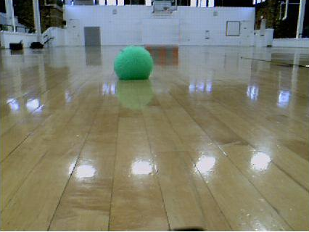
Figure 2: Image with green fuzzy ball

that object as a red cup. In terms of image processing, this requires that the pixels of the image which represent the red cup must be separable from the rest of the image and be identified as a cohesive unit. This process is known as color segmentation.

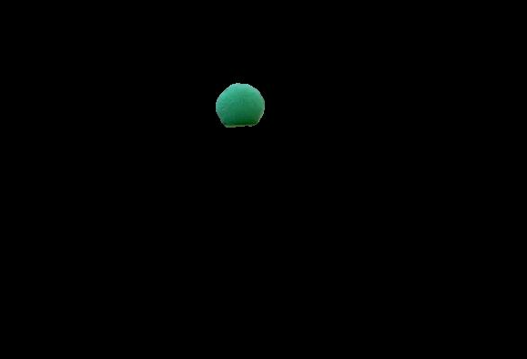
Figure 3: Fuzzy ball image segmented into x clusters

MATLAB has many image processing functions useful to this goal, but there is no one function that can be called to accomplish this task. On the other hand, there is a large and very active MATLAB user community which shares code. In statistics there is a pattern recognition process known as k-means clustering [xxx ...] which, given a value k, through an iterative process collects data points into k clusters, such that all the data points in one cluster are more closely related to each other than they are to data points in other clusters.

Figures 2, 3 and 4 illustrate this process. In Figure 2 we see a fuzzy green ball we would like our robot to be able to identify. Although to our eyes this object stands out very sharply against its background, on a pixel by pixel basis, it turns that that there are many pixels in the image which have a degree of commonality with those of the ball and these must be filtered out. The tan hue of the gym floor is closer in hue to the green of the ball and must be separated out. And, if we are interested in the shape of the ball, we do not want the reflection of the ball on the gym floor to be included in the pixels representing the ball. In addition, there are clear gradations of color and brightness within the ball itself which can get separated and again distort the shape of the ball.
Figure 3 shows what can result if too small a value is chosen for k. In Figure 4 we can see the pixels of the ball clearly emerging when the proper value for k is used.

Figure 4: Fuzzy ball image segmented into y clusters

4.2. Color Signature and Object recognition
Color segmentation is the first step to object recognition. The next step is to match the object segmented at one point in time to the same object at a later time. Is it the same object or a different one? Shape, of course, is a powerful clue, but there can be objects with the same shape but of different colors.
The task of matching objects by color has many aspects, but the key question is how close is close enough when comparing two sets of pixels. The problem is made more difficult by the fact that the RGB color representation combines representation of hue and brightness in such a way that it is more difficult to isolate the color component of an image for comparison purposes. There are two color representation systems, yCbCr and L*A*B*, both of which are supported by MATLAB, which are closer in their representation to the way our eyes see color. These were investigated for use in object recognition by color.
The process of determining the extent of match between two regions of pixels was based on the idea of calculating a "color signature" for each and then applying a comparison metric. All three color representation systems mentioned above store each pixel as a triple with the result being that an image is a two dimensional array of triples. MATLAB permits one to separate the image into three two dimensional arrays, with each array containing one component of the pixel's triple. The three arrays are called channels. For both the yCbCr and the L*A*B* only two of the channels contain color information while the third channel represents brightness.
It turned out that each of the two representations gave better match results on only one of the color channels while the other performed better on the other channel. It was decided to use both representation schemes, combining the results of each. The formula used is given in Figure 5.

probability = pmcb*pmlb*psdcb*psdlb;
pmcb = min(cbMean1,cbMean2)/max(cbMean1,cbMean2)
pmlb = min(lbMean1,lbMean2)/max(lbMean1,lbMean2)
psdcb = min(cbStd1,cbStd2)/max(cbStd1,cbStd2)
psdlb = min(lbStd1,lbStd2)/max(lbStd1,lbStd2)
where
cbMeanx and cbStdx are the mean and standard
deviation of images 1 and 2 for yCbCr, and
lbMeanx and lbStdx are the mean and standard
deviation of images 1 and 2 for L*A*B*

Since the four separate probabilities are multiplied together creating an artificially low value, the threshhold used for determining a match is lower than one would normally accept. For example a value of 0.7676 would indicate a match, keeping in mind that non-matching colors would yield much lower values.

4. The Robotics Course
This section will be about design and implementation of the course.

5. PACT Demonstration
This section will describe the experiences of the PACT demo.
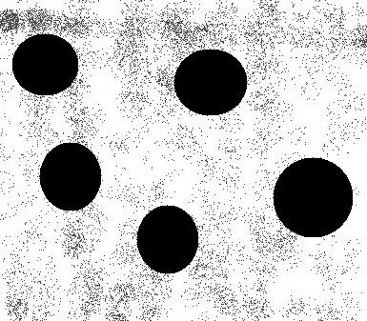
Figure 2: Test picture with multiple circles on textured background

6.2. Ontology-based world knowledge
How the world info would be stored

6.3. Blackboard implemented behavior based control
The set of behaviors and their implementation in a blackboard task scheduling system.

7. Robot-Human Communication
This section will be about the use of image processing to guide the robot.

7.1. Communication Theory
What is communication, how it is to take place, etc.

7.2. Semantic Parsing
Theory and examples

7.3. Establishing co-referents
How image processing & semantics are combined to give robot and human common points and objects of reference in the shared environment.

7. Assessment
What we learned and recommendations, including outline of proposed Intel. Rob. course, CSC445.

8. Future Work
Where this course may go in the future

9. References
[x1] Touretzky, David S. Preparing Computer Science Students for the Robotics Revolution. Communications of the ACM (CACM), 53(8):27-29, August, 2010.

[x2] Gates, B. A robot in every home. Scientific American
(Jan. 2007), 58–65, January 2007.

[x1] Blank, Douglas. Robots Make Computer Science Personal. Communications of the ACM (CACM), 49(12):25-27, December, 2006.

[x3] Gonzalez, Rafael C, Woods, Richard E. and Eddins, Steven L. Digital Image Processing Using MATLAB, 2nd Ed. Knoxville, TN: Gatesmark Publishing (2009).

[x4 Bradski, Gary and Kaehler, Adrian. Learning OpenCV: Computer Vision with the OpenCV Library. Sebastopol, CA: O'Reilly Media (2008).

[x5 Wahlster, Wolfgang (ed.). SmartKom: Foundations of Multimodal Dialogue Systems. New York: Springer Verlag (2006).

[6]Feature Detection — OpenCV 2.0 C++ Reference. (n.d.). Retrieved February 9, 2010, from http://opencv.willowgarage.com/documentation/cpp/feature_detection.html#houghcircles

Deleted material - some of this may need to be put back in somewhere:
The most recent effort was a special topics course in Intelligent Robotics, funded in large part by grants from the PASSHE Faculty Professional Development Committee and Tyco Electronic Foundation, which formed the basis for proposing an intelligent robotics course as a permanent part of the computer science curriculum. We report here on the development of that course and on the design of the proposed course.

2. Early Experience
At this point it was clear that there was significant student interest in robotics. In addition the success of the DARPA Grand Challenge, the growth of the robotics industry and widespread interest in its continued development, as evidenced by the Congressional Robotics Caucus, all provided impetus to keep searching for the right approach. During this time frame the second author built a robot to enter the Trinity Robot Firefighting Contest. With funds from the Kutztown University Undergraduate Research Committee, augmented by funds from the Tyco grant, he rebuilt the chasis from a Vex robot kit to hold an EEE netbook computer, an Arduino microcontroller chip and a XXX camera. [... Jeff - can you add more here? ...]
Early in the spring of 2010 major commitment was made to the Myro robotic system developed by Georgia Tech and Bryn Mawr College. These robots consisted of the Scribbler robot as chasis and the Myro Fluke providing programming capability via Python and the basics of image processing as part of the Myro package. Five copies were purchased with grant funds and distributed to teams in an artificial intelligence class. In fairness to the developers of Myro, it must be pointed out that target audience of its developers was the CS1 class [xxx7]. It turned out that the hardware, even with the supplied software interface, was unable to provide the basis for the kinds of projects one would want in an A.I. course. The drive motors for the wheels were too iffy to allow a program to set a course and expect to achieve it. The image from the camera on the Fluke was of insufficient quality to provide the basis for , etc. etc.

Also notes . . .
The basic robotic unit consists of a Create robot with an EEE netbook, a Microsoft Lifecam and an Arduino microcontroller riding on the Create on a platform designed and built by the University's Carpenter Shop, as shown in Figure 1. The purpose of adding the Arduino is to permit the addition of sensors to give the robot greater operational flexibility. For example, since the Create does not have viable distance sensors, an infrared (IR) sensor was added, with the data from this sensor being passed through the microcontroller to the onboard computer.

Notes:
Harnad's symbol grounding problem
Beer's SED framework

